Unix and Shell programming
Commands

- Date Command
Description: This command is generally used to display the system date and time.
Syntax - $ date [options]…[+formate]
Options of date command:
- date –date- using -date option for displaying past date
- date –s- this option is used to set system date and time
- date –r- This is used to display the last modified timestamp of a datefile
- date –u- Display the time in coordinated universal time zone
Formate specifier used with date command:
- date +%a- The abbreviated name (Sun)
- date +%A- The full month name (Sunday)
- date +%b- The abbreviated month name (Jan)
- date +%B- Displays full month name
- date +%C- The current century
- date +%w- Day of week(0….6); {0 is Sunday}
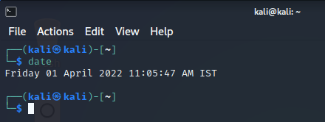

2. whoami Command
Description: The whoami command simply prints the effective user ID.
Syntax - $ whoami
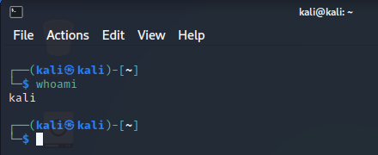
3.Who command
Description: Prints the information about users who are currently logged in.
Syntax - $ who [options] [filename]
Options of who command:
- Who –a- It shows current user
- Who –H- Prints a line of column heading
- Who –q- Display all login names, and a count of all logged-in users
- Who –b- Display the time of last system boot
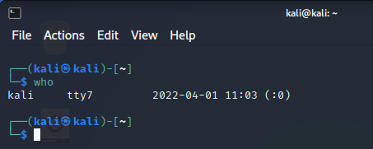

4. Users command
Description: Prints the information about users who are currently logged in according to file.
Syntax - $ user [options] [filename]
Options of user command:
- users –help- This user will display the help message and exit
- users –version- This option will show the version information and exit
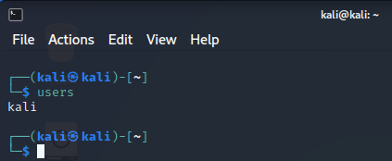

5.Cal command
Description: Display a simple formatted calendar in your terminal. Syntax - $ cal [options] [[[day]month]year]
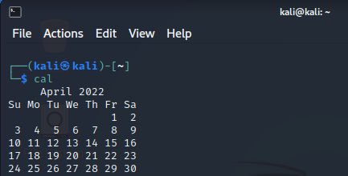
Options of cal command:
- cal –1- Display single month output
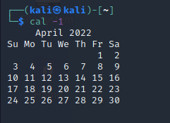
- cal –3- Display a simple, formatted calendar in your terminal
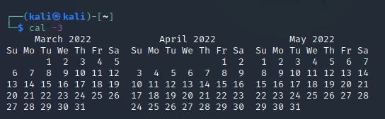
- cal –s- Display Sunday as the first day of the week
- cal –m- Display Monday as the first day of the week

6. echo command:
Description: Echo command is to display line of text/string that are passed as an argument.
Syntax - $ echo [string] [filename]
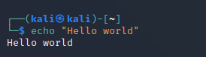
7. ls command
Description: List directory content.
Syntax - $ ls [options] [filename]
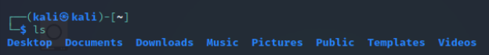
Options of ls command:
- ls – l- To show long listing information about file\directory
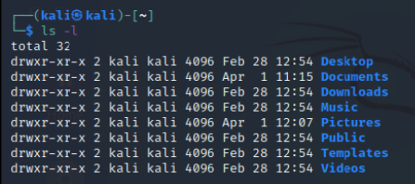
- ls – a- List all files including hidden file starting with ‘.’
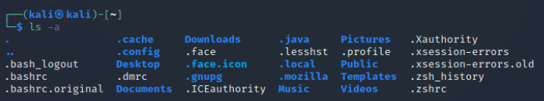
- ls – r- List in reverse order
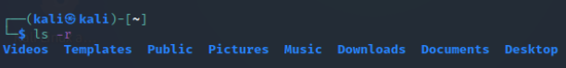
- ls – s- Sort by file size
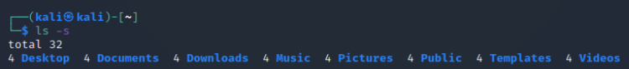
8. cat command
Description: It is used to create, display and concatenate file contents.
Syntax - $ cat [options] [filename]
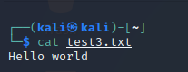
Options of cat command:
- cat –b- Omits line numbers for blank space in the output
- cat –E- Display a dollar sign ($) at the end of each line
- cat –n- Line numbers for all the output lines
- cat –s- Suppress repeated empty output lines
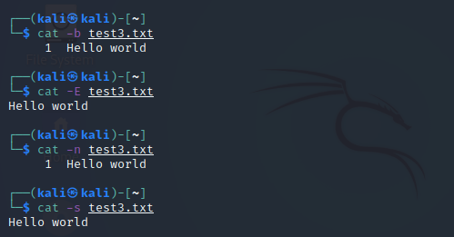

9. clear command
Description: Clear command is used to clear the terminal screen.
Syntax - $ clear
10. pwd command
Description: pwd stands for prints working directory. It prints the path of the working directory, starting from the root.
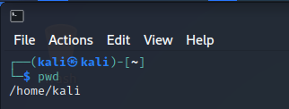
Syntax - $ pwd [options]
Options of pwd command:
- pwd –L- Prints the symbolic path
- pwd –P- Prints the actual path
11. mkdir command
Description: mkdir command allows the user to create directories. This command can create multiple directories at once as well as set the permission for the directories.
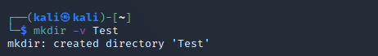
Syntax - $ mkdir [options] [directory]
Options of mkdir command:
- mkdir –v- It displays a message for every directory created.
- mkdir –p- A flag which enables the command to create parent directory.
- mkdir –m- This option is used to set the file modes, i.e. permission etc, for create directory.

12. man command
Description: Man command is used to display the user manual of any command that we can run on the terminal.
Syntax - $ man [options] [commandname]
Options of man command:
- man –a – One may not be able to remember the sections in which a command is present.
- man –f – This option help us to display all the available intro manual pages in succession.
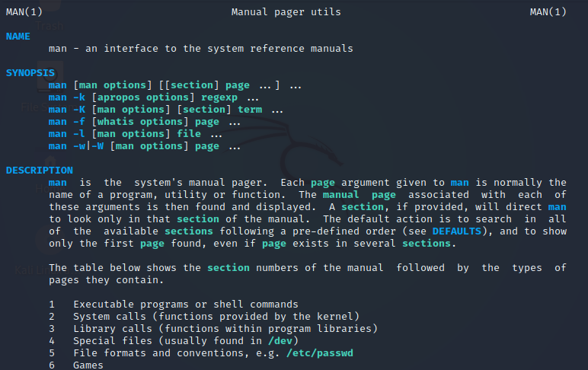

13. uname command
Description: The command uname displays the information about the system.
Syntax - $ uname [commandname]
Options of uname command:
- uname –s – It prints the kernel name.
- uname –n – It prints the hostname of the network node.
- uname –v – It prints the version of the current kernel.
- uname –m – It prints the machine hardware name.
- uname –o – It prints the name of the operating system.
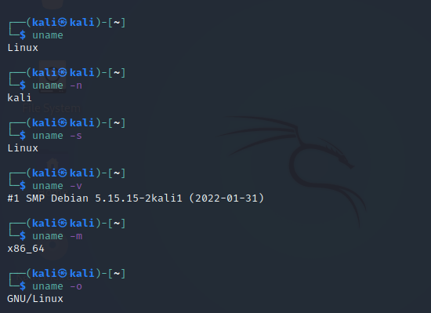
14. passwd command
Description: passwd command is used to change the user account password.
Syntax - $ passwd [username]
15. rm command
Description: rm stands for remove, it is used to remove objects such as files, directories.
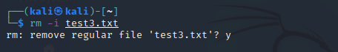
Syntax - $ rm [option][filename]
Options of rm command:
- rm –i – (Interactive deletion) ask the user for confirmation before removing each file.
- rm –f – Override the minor protection and removes the file forcefully.
- rm –r – (Recursive deletion) Delete all files and sub-directories recursively of the parent directory.
- rm –d – Remove empty directories.

16. cd command
Description: cd command is used to change the current directory.
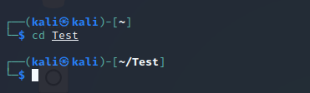
Syntax - $ cd [option][directory]
Options of cd command:
- cd.. – Change current directory to parent directory.
- cd~ – Move to users home directory from anywhere.
- cd Test – Change from current working directory to Test.
- cd../download – If we are currently in home/username/documents then we would be placed in home/username/downloads.
17. cp command
Description: cp command is used for copy files or group of files or directory.
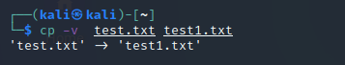
Syntax - $ cp [option][filename]
Options of cp command:
- cp -i – With this option system first warns the user before overwriting the destination file.
- cp -f– If the system is unable to open destination file for writing operation because the user doesn’t have writing permission for this file then by using -f option with cp command, destination file is deleted first and then copying of content is done from source to destination file.
- cp -b– With this option cp command creates the backup of the destination file in the same folder with the different name and in different format.
- cp -r– Copying directory structure. With this option cp command shows its recursive behavior by copying the entire directory structure recursively.
18. mv command
Description: mv stands for move. mv is used to move one or more files or directories from one place to another in a file system.
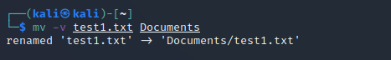
Syntax - $ mv [option][filename]
Options of mv command:
- mv -i – With this option system first warns the user before overwriting the destination file.
- mv -f– The -f option overrides this minor protection and overwrites the destination file forcefully and deletes the source file.
- mv -n– With -n option, mv prevent an existing file from being overwritten.
- mv -b– With this option, it is easier to take a backup of an existing file that will be overwritten as a result of the mv command.
19. cut command
Description: The cut command in UNIX is a command for cutting out the sections from each line of files and writing the result to standard output. It can be used to cut parts of a line by byte position, character and field.
Syntax - $ cut [option][filename]
Options of cut command:
- cut -b – To extract the specific bytes, you need to follow -b option with the list of byte numbers separated by comma.
- cut -c– To cut by character use the -c option. This selects the characters given to the -c option.
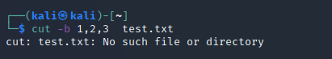
20. paste command
Description: It is used to join files horizontally (parallel merging) by outputting lines consisting of lines from each file specified, separated by tab as delimiter, to the standard output.
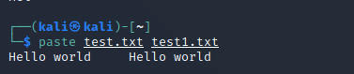
Syntax - $ paste [option][filename]
Options of paste command:
- paste -d – Paste command uses the tab delimiter by default for merging the files. The delimiter can be changed to any other character by using the -d option.
- paste -s– We can merge the files in sequentially manner using the -s option. It reads all the lines from a single file and merges all these lines into a single line with each line separated by tab. And these single lines are separated by newline.

